Project Proposal
Project Title: ModelForge AI — Cloud-Based Deep Learning Model Compiler & Deployment Platform
Team Members
- Vanshika Panjwani 34152
- Aradhya Ranjan 34162
- Sanskriti Gupta 34165
Abstract
Deep Learning models are commonly developed and trained using frameworks such as PyTorch, but deploying the same model across different hardware platforms often requires framework-specific conversions and optimization. This creates additional development effort and makes deployment less portable.
This project proposes a cloud-based Deep Learning model conversion and optimization platform using ONNX (Open Neural Network Exchange) as an intermediate representation. A Deep Learning model will first be trained using PyTorch on a selected dataset, producing a trained .pt model. The model will then be exported to ONNX, which provides a common representation of the model's computational graph and facilitates deployment across different environments.
The proposed platform will use cloud services to automate the conversion process. After an ONNX model is uploaded, cloud-based event-driven services will initiate independent conversion pipelines for TensorFlow Lite (TFLite), TensorRT, and Core ML. Each pipeline will run in an isolated Docker container and perform platform-specific optimization such as FP16 or INT8 quantization where applicable.
The system will also benchmark the original and converted models using metrics such as model size, inference latency, and accuracy. The results will be stored and presented through a web-based dashboard, allowing users to compare different deployment formats and select an appropriate model for their target platform.
The project therefore combines two major components: Deep Learning model development using PyTorch and Cloud Computing for automated, scalable model conversion and deployment.
Keywords
Deep Learning, PyTorch, ONNX, Model Conversion, Model Optimization, Cloud Computing, TensorFlow Lite, TensorRT, Core ML, Docker, AWS, Serverless Architecture, Model Benchmarking, Computer Vision
Technology Required
1. Deep Learning
- Python
- PyTorch – training the Deep Learning model
- TorchVision – dataset and computer-vision utilities where required
- CNN / ResNet – base Deep Learning architecture
- CUDA – optional GPU acceleration during training
- ONNX / ONNX Runtime – model export, validation and inference
The project will train an actual Deep Learning model rather than starting with an externally trained model. PyTorch provides the framework for building and training neural networks, while ONNX provides a standardized intermediate representation for model deployment.
2. Model Conversion and Optimization
- ONNX
- ONNX Runtime
- TensorFlow / TensorFlow Lite
- TensorRT
- Core ML Tools
- FP16 / INT8 quantization
- Model validation and operator compatibility checking
ONNX is particularly suitable for this architecture because it is designed as a common representation that allows models to move between frameworks and deployment environments.
3. Cloud Computing
The primary cloud platform will be Amazon Web Services (AWS).
Required services:
- Amazon S3 – model and result storage
- Amazon EventBridge – event-driven workflow initiation
- Amazon SQS – job queues
- AWS Lambda – lightweight orchestration
- Amazon ECS – execution of containerized conversion jobs
- EC2 GPU instances – TensorRT/GPU-based conversion where required
- Amazon ECR – Docker image registry
- Amazon RDS / PostgreSQL – job and benchmark metadata
- IAM – authentication and access control
- CloudWatch – logging and monitoring
Amazon S3 can generate object-created events that can be consumed through EventBridge, making it suitable for triggering the conversion workflow automatically after an ONNX model is uploaded.
4. Backend and Frontend
- FastAPI – REST API
- PostgreSQL – job and benchmark metadata
- React / Streamlit – web dashboard
- Boto3 – AWS integration
- Docker – isolated conversion environments
- Git/GitHub – version control and collaboration

Architecture
The proposed architecture follows an event-driven cloud pipeline.
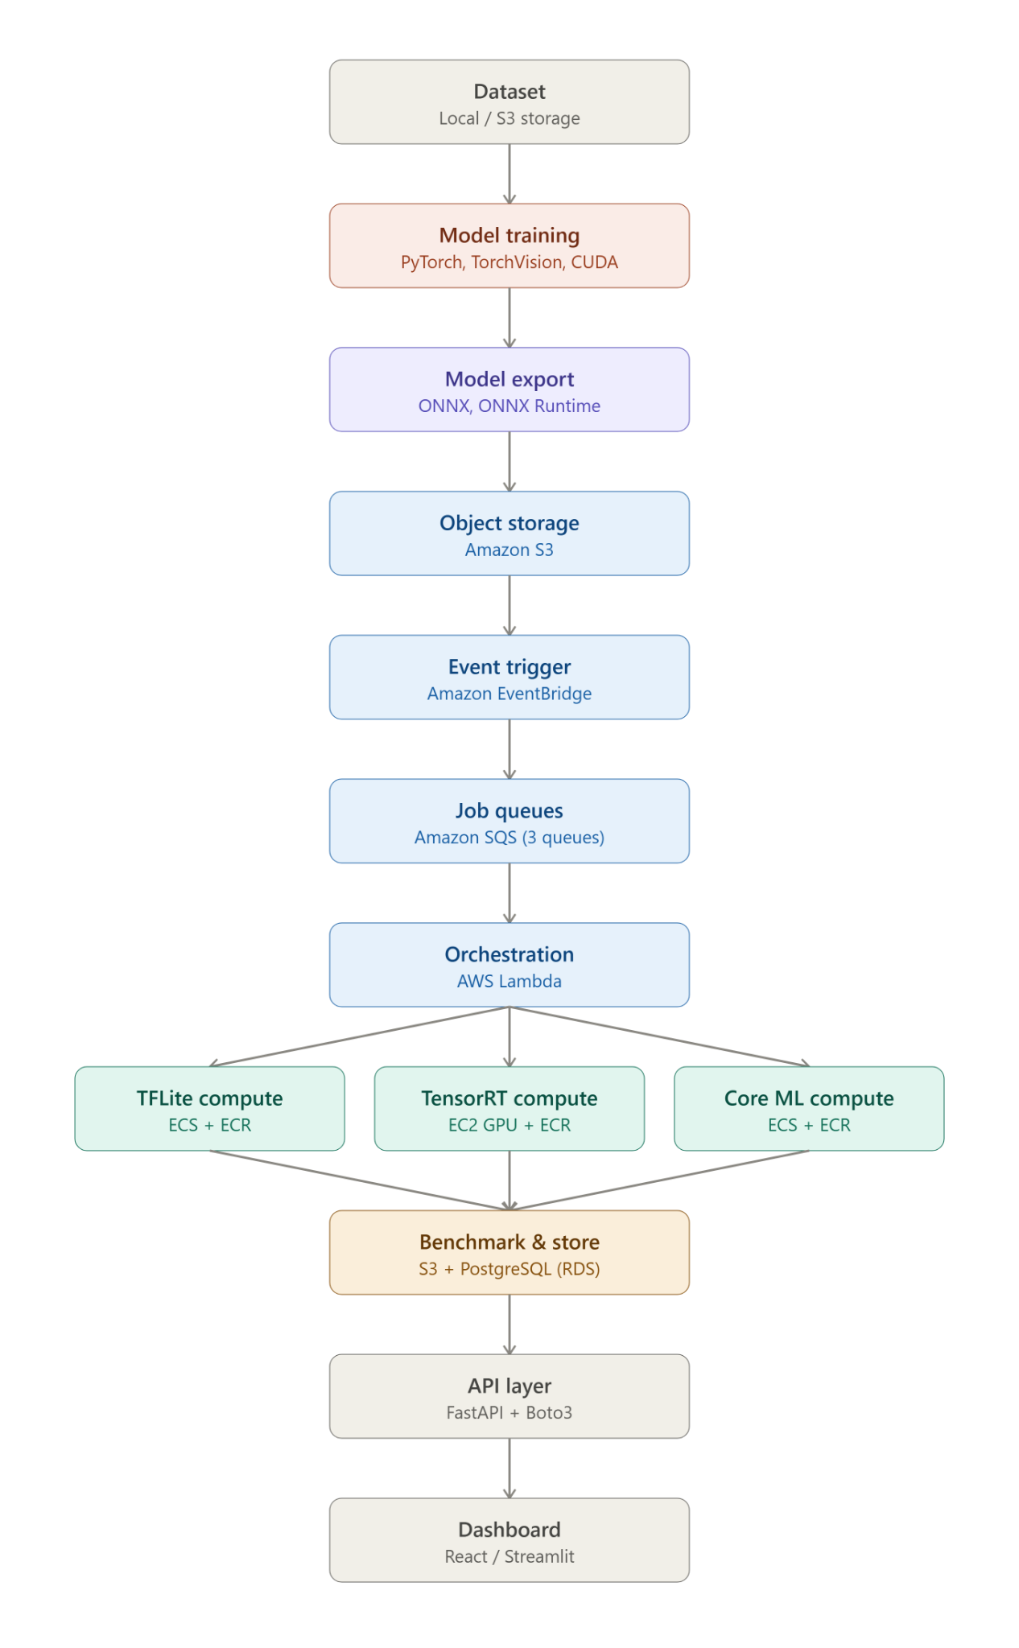
LAYER WISE END TO END FLOW ARCHITECTURE
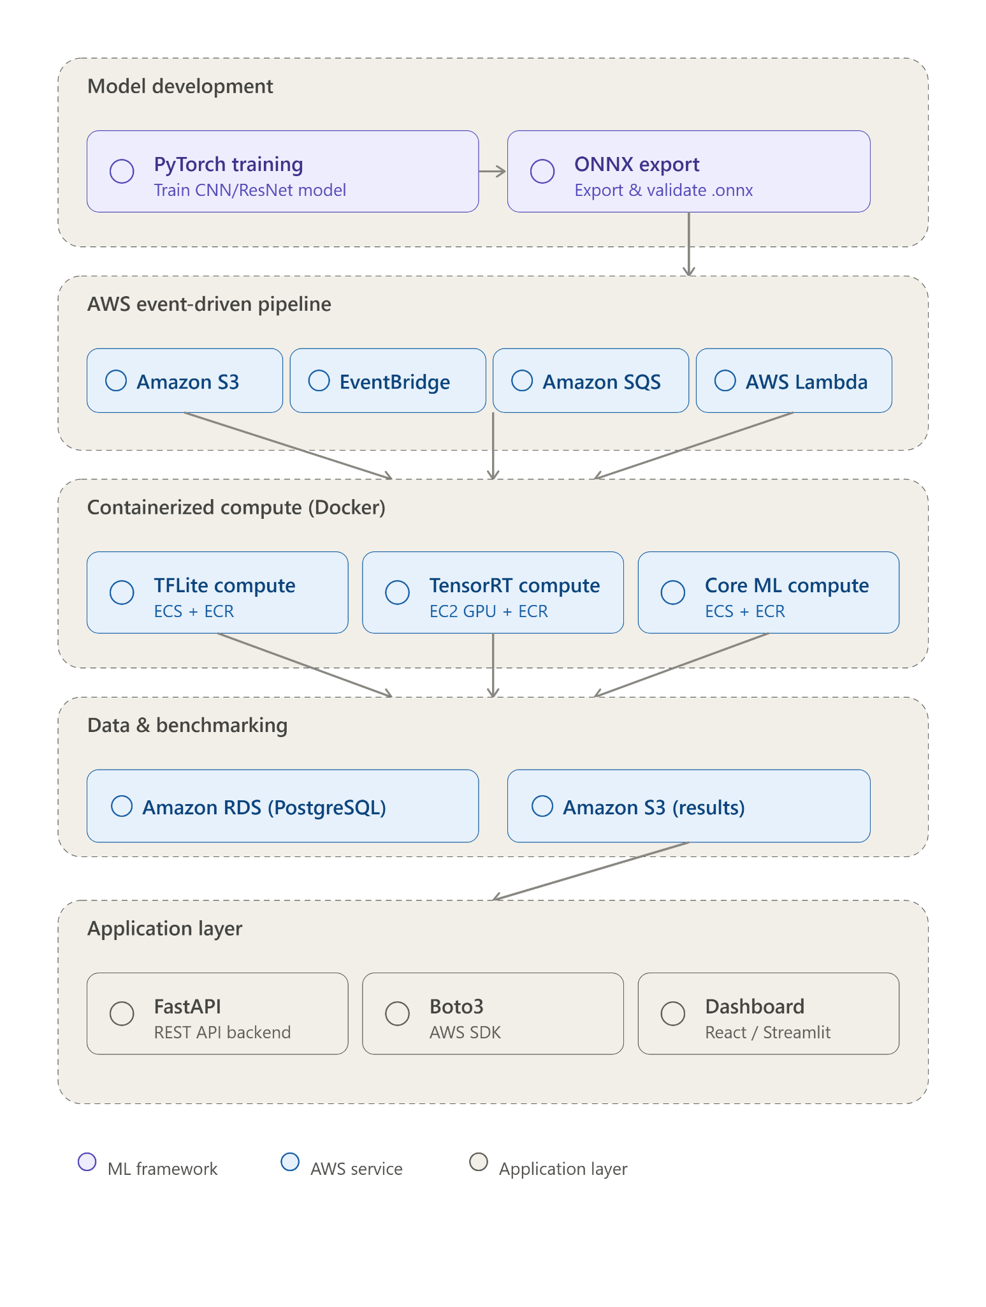
Architecture Flow:
- A dataset is used to train a CNN/ResNet model using PyTorch.
- The trained .pt model is exported and validated as an ONNX model.
- The ONNX model is uploaded to Amazon S3.
- The S3 upload generates an event that is processed by EventBridge.
- EventBridge routes the job to independent SQS queues for TFLite, TensorRT and Core ML.
- Lambda functions consume the jobs and start the appropriate ECS conversion task.
- Each conversion runs inside an isolated Docker container.
- The converted model is stored back in S3.
- A common benchmarking module evaluates the models using:
  - Accuracy
  - Inference latency
  - Model size
  - Memory/resource usage where measurable
- Benchmark results are stored in PostgreSQL.
- The dashboard retrieves the results through the FastAPI backend and allows users to compare and download the generated models.
Expected Outcome
The final system will provide a working cloud-based pipeline in which a trained Deep Learning model can be transformed from:
PyTorch → ONNX → TFLite / TensorRT / Core ML
while automatically executing the conversion and benchmarking processes in the cloud.
The project will demonstrate both:
- Deep Learning: model design, training, evaluation and export using PyTorch.
- Cloud Computing: object storage, event-driven processing, queues, serverless orchestration, containers, cloud databases and scalable model-conversion workloads.
References
- ONNX Documentation – Introduction and Concepts
ONNX provides an open representation for machine-learning models and supports interoperability between different frameworks and deployment environments.
- PyTorch Documentation
PyTorch is an optimized tensor library and Deep Learning framework supporting model development, training and deployment.
- AWS Documentation – Amazon S3 Events with EventBridge
AWS documentation describing how S3 object events can be delivered to EventBridge for event-driven processing.
- AWS Documentation – Amazon S3 Event Notifications
Documentation covering S3 event notifications and supported destinations such as SQS, SNS, Lambda and EventBridge.
- ONNX – Get Started
Official ONNX documentation describing the workflow of building a model, exporting it to ONNX, performing inference and exporting to another framework.

